**SIMULATION OF INVENTORY PROBLEMS - QUANTITATIVE TECHNIQUES FOR MANAGEMENT**

A dealer of electrical appliances has a certain product for which the probability distribution of demand per day and the probability distribution of the lead-time, developed by past records are as shown in the following tables.

***Probability distribution of lead demand***

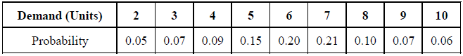

***Probability distribution of lead time***

Probability distribution of lead time

The various costs involved are,  
Ordering Cost = Rs. 50 per order  
Holding Cost = Rs.1 per unit per day  
Shortage Cost = Rs. 20 per unit per day

Simulation Problems and Solutions in Operations Research

The simulation problems and solutions in operational research are given below

The dealer is interested in having an inventory policy with two parameters, the reorder point and the order quantity, i.e., at what level of existing inventory should an order be placed and the number of units to be ordered. Evaluate a simulation plan for 35 days, which calls for a reorder quantity of 35 units and a re-order level of 20 units, with a beginning inventory balance of 45 units.

***Solution:***Assigning of random number intervals for the demand distribution and lead time distribution is shown in Tables 15.25 and 15.26 respectively.

***Random Numbers Assigned for Demand Per Day***

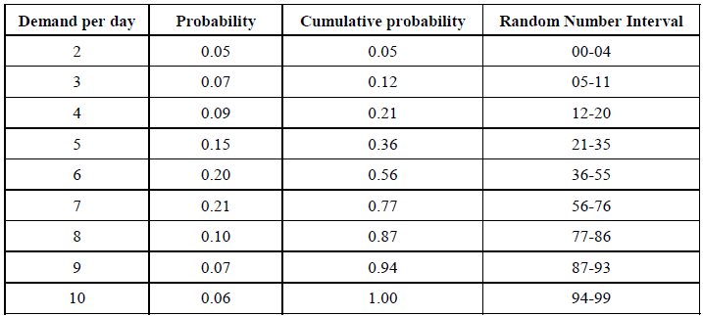

***Random Numbers Assigned for Lead-time***

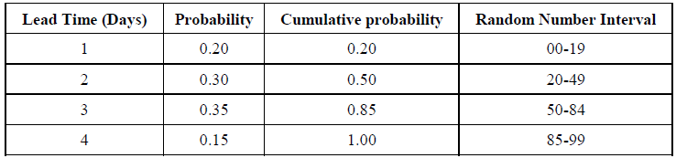

***Simulation Work-sheet for Inventory Problem (Case – 1)***

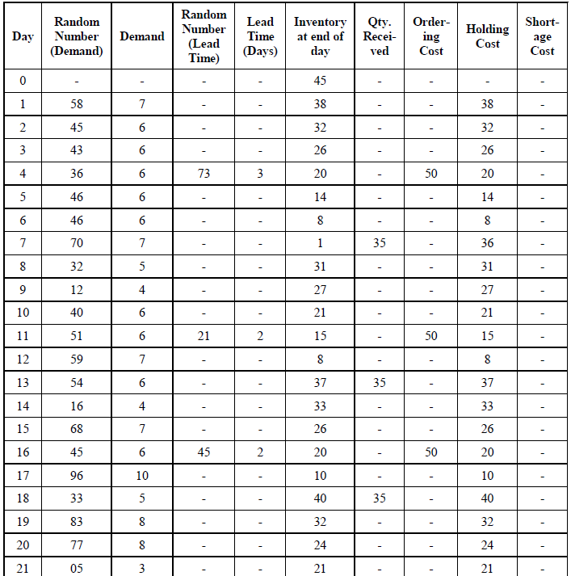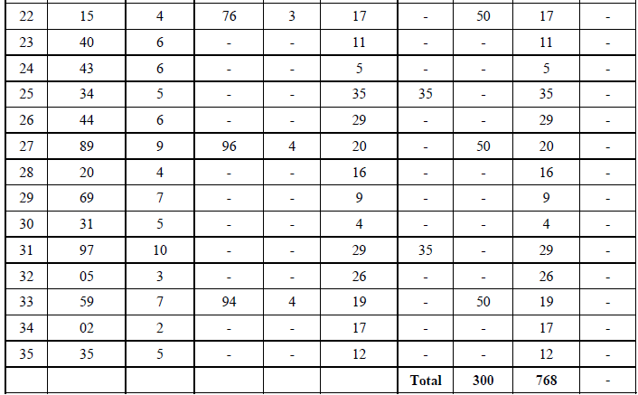

Reorder Quantity = 35 units, Reorder Level = 20 units, Beginning Inventory = 45 units

***Simulation Work-sheet for Inventory Problem (Case – II)***

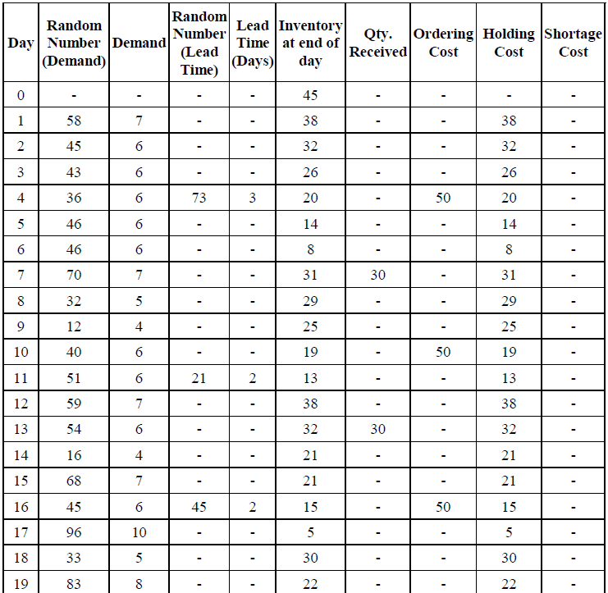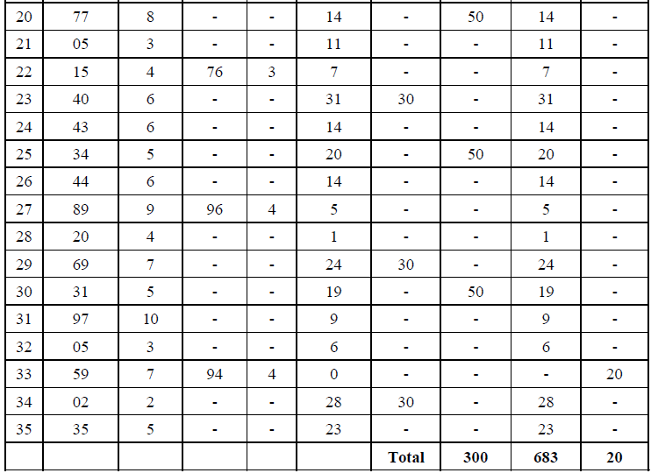

Reorder Quantity = 30 units, Reorder Level = 20 units, Beginning Inventory = 45 units

The simulation of 35 days with an inventory policy of reordering quantity of 35 units at the time of inventory level at the end of day is 20 units, as worked out in table. The table explains the demand inventory level, quantity received, ordering cost, holding cost and shortage cost for each day.

Completing a 35 day period, the costs are

Total ordering cost = (6 × 50) = Rs 300.00  
Total holding cost = Rs. 768.00

Since the demand for each day is satisfied, there is no shortage cost.

Therefore, Total cost = 300 + 768  
= Rs. 1068.00

For a different set of parameters, with a re-order quantity of 30 units and the same reorder level of 20 units, if the 35-day simulation is performed, we get the total of various costs as shown in the previous table.

Total ordering cost = 6 × 50 = Rs. 300.00  
Total holding cost = Rs. 683.0  
Total shortage cost = Rs. 20.00

Therefore,

Total cost = 300 + 683 + 20  
= Rs. 1003.00

If we analyze the combination of both the parameters, Case II has lesser total cost than Case I. But at the same time, it does not satisfy the demand on 33rd day that might cause customer dissatisfaction which may lead to some cost.

In this type of problems, the approach with various combinations of two parameter values is simulated a large number of times to find the total cost of each experiment, compare the total cost and select the optimum alternative, i.e., that one which incurs the lowest cost.

***Example :***Mr. Srinivasan, owner of Citizens restaurant is thinking of introducing separate coffee shop facility in his restaurant. The manager plans for one service counter for the coffee shop customers. A market study has projected the inter-arrival times at the restaurant as given in the table. The counter can service the customers at the following rate:

Simulation Problem with Solution

***Simulation of Queuing Problem***

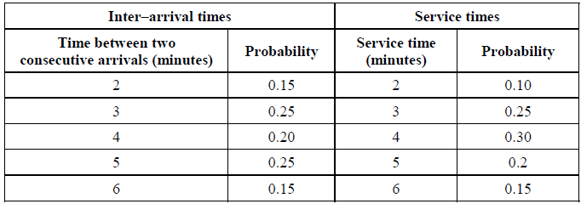

Mr. Srinivasan will implement the plan if the average waiting time of customers in the system is less than 5 minutes. Before implementing the plan, Mr. Srinivasan would like to know the following:

1. Mean waiting time of customers, before service.
2. Average service time.
3. Average idle time of service.
4. The time spent by the customer in the system.

Simulate the operation of the facility for customer arriving sample of 20 cars when the restaurant starts at 7.00 pm every day and find whether Mr. Srinivasan will go for the plan.

***Solution:***Allot the random numbers to various inter-arrival service times as shown in table.

***Random Numbers Allocated to Various Inter-Arrival Service Times***

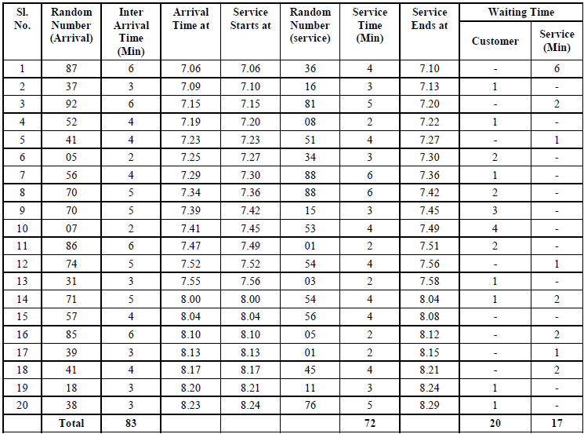

1. Mean waiting time of customer before service = 20/20 = 1 minute
2. Average service idle time = 17/20 = 0.85 minutes
3. Time spent by the customer in the system = 3.6 + 1 = 4.6 minutes.

***Example :***Dr. Strong, a dentist schedules all his patients for 30 minute appointments. Some of the patients take more or less than 30 minutes depending on the type of dental work to be done. The following table shows the summary of the various categories of work, their probabilities and the time actually needed to complete the work.

***Simulation Problem***

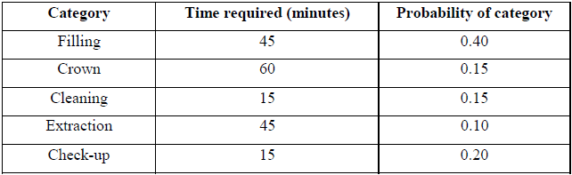

Simulate the dentist’s clinic for four hours and determine the average waiting time for the patients as well as the idleness of the doctor. Assume that all the patients show up at the clinic exactly at their scheduled arrival time, starting at 8.00 am. Use the following random numbers for handling the above problem: 40, 82, 11, 34, 25, 66, 17, 79

***Solution:***Assign the random number intervals to the various categories of work as shown in table.

***Random Number Intervals Assigned to the Various Categories***

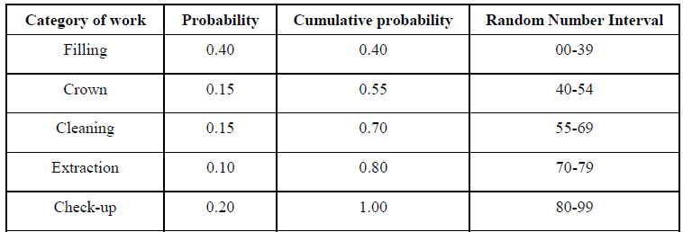

*Assuming the dentist clinic starts at 8.00 am, the arrival pattern and the service category are shown in table.*

***Arrival Pattern of the Patients***

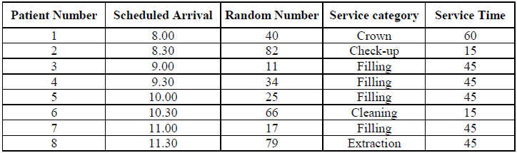

***The arrival, departure patterns and patients’ waiting time are tabulated.***

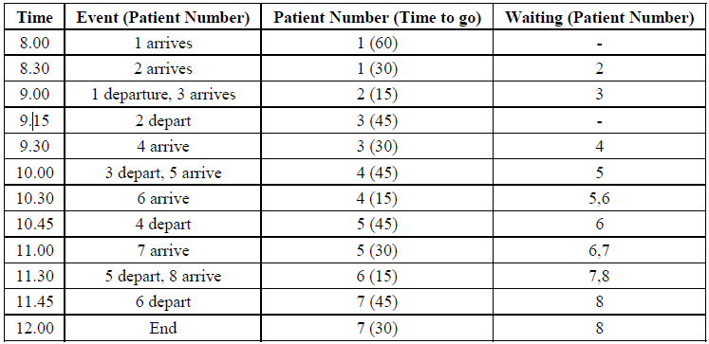

The dentist was not idle during the simulation period. The waiting times for the patients are as given in table below.

***Patient's Waiting Time***

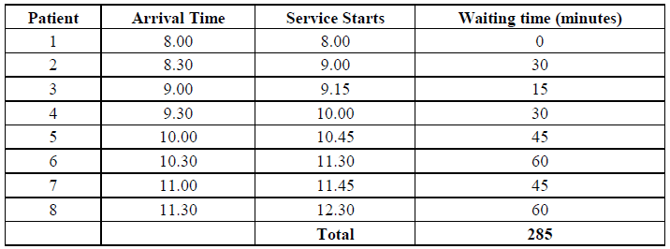

The average waiting time of patients = 285/8  
= 35.625 minutes.

## Simulation Problems and Solutions in Operations Research

The simulation problems and solutions in operations research are mentioned below

**Example :**An ice-cream parlor's record of previous month’s sale of a particular variety of ice cream as follows (see Table).

**Simulation of Demand Problem**

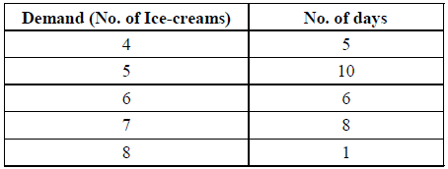

Simulate the demand for first 10 days of the month

**Solution:**Find the probability distribution of demand by expressing the frequencies in terms of proportion. Divide each value by 30. The demand per day has the following distribution as shown in table.

**Probability Distribution of Demand**

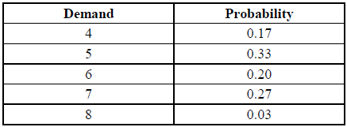

Find the cumulative probability and assign a set of random number intervals to various demand levels. The probability figures are in two digits, hence we use two digit random numbers taken from a random number table. The random numbers are selected from the table from any row or column, but in a consecutive manner and random intervals are set using the cumulative probability distribution as shown in Table.

**Cumulative Probability Distribution**

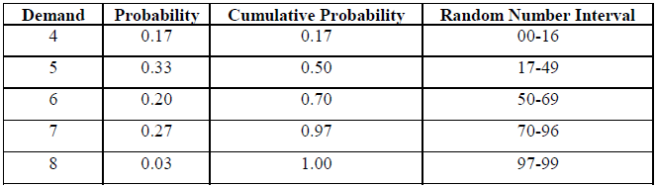

To simulate the demand for ten days, select ten random numbers from random number tables. The random numbers selected are, 17, 46, 85, 09, 50, 58, 04, 77, 69 and 74 The first random number selected, 7 lies between the random number interval 17-49 corresponding to a demand of 5 ice-creams per day. Hence, the demand for day one is 5. Similarly, the demand for the remaining days is simulated as shown in Table.

**Demand Simulation**

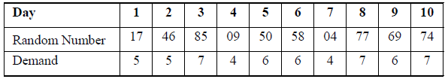

**Example :**A dealer sells a particular model of washing machine for which the probability distribution of daily demand is as given in Table.

**Probability Distribution of Daily Demand**



## Simulation Problems using Random numbers

The simulation problems using random numbers are given below

Find the average demand of washing machines per day.

**Solution:**Assign sets of two digit random numbers to demand levels as shown in Table.

**Random Numbers Assigned to Demand**

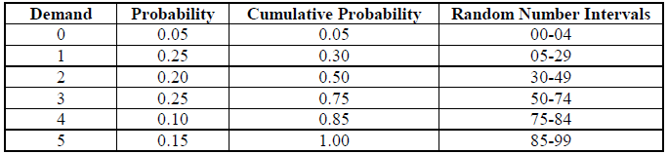

Ten random numbers that have been selected from random number tables are 68, 47, 92, 76, 86, 46, 16, 28, 35, 54. To find the demand for ten days see the Table below.

**Table 15.7: Ten Random Numbers Selected**

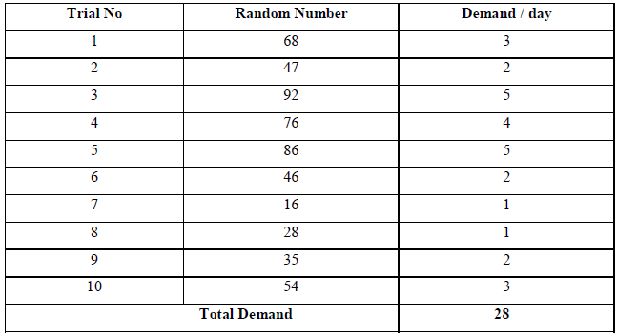

Average demand =28/10 =2.8 washing machines per day. The expected demand /day can be computed as,  
Expected demand per day

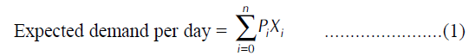

where, pi = probability and xi = demand

= (0.05 × 0) + (0.25 × 1) + (0.20 × 2) + (0.25 × 3) + (0.1 × 4) + (0.15 × 5)  
= 2.55 washing machines.

The average demand of 2.8 washing machines using ten-day simulation differs significantly when compared to the expected daily demand. If the simulation is repeated number of times, the answer would get closer to the expected daily demand.

**Example :**A farmer has 10 acres of agricultural land and is cultivating tomatoes on the entire land. Due to fluctuation in water availability, the yield per acre differs. The probability distribution yields are given below:

1. The farmer is interested to know the yield for the next 12 months if the same water availability exists. Simulate the average yield using the following random numbers 50, 28, 68, 36, 90, 62, 27, 50, 18, 36, 61 and 21, given in table.

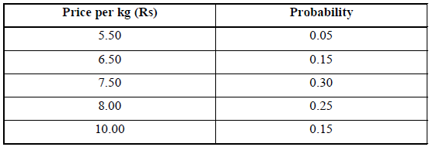

b. Due to fluctuating market price, the price per kg of tomatoes varies from Rs. 5.00 to Rs. 10.00 per kg. The probability of price variations is given in the Table below. Simulate the price for next 12 months to determine the revenue per acre. Also find the average revenue per acre. Use the following random numbers 53, 74, 05, 71, 06, 49, 11, 13, 62, 69, 85 and 69.

**Simulation Problem**

**Solution:**

**Table for Random Number Interval for Yield**

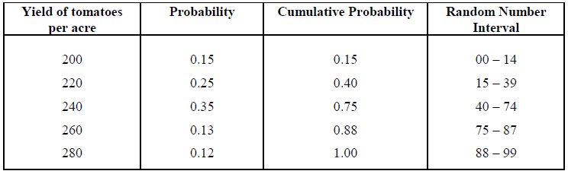

***Table for Random Number Interval for Price***

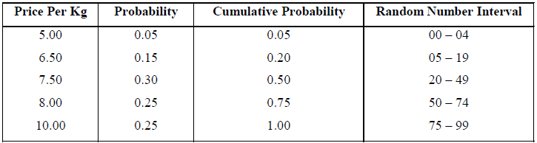

***Simulation for 12 months period***

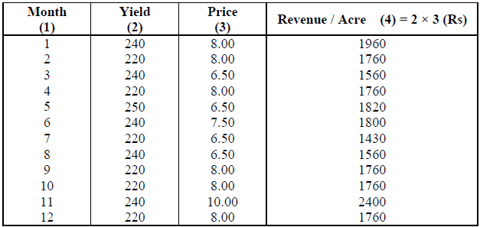

Average revenue per acre = 21330 / 12  
= Rs. 1777.50

**Example :**J.M Bakers has to supply only 200 pizzas every day to their outlet situated in city bazaar. The production of pizzas varies due to the availability of raw materials and labor for which the probability distribution of production by observation made is as follows:

**Simulation Problem**

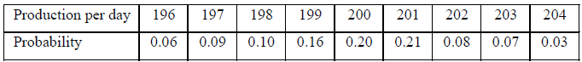

Simulate and find the average number of pizzas produced more than the requirement and the average number of shortage of pizzas supplied to the outlet.

**Solution:**Assign two digit random numbers to the demand levels as shown in table

**Random Numbers Assigned to the Demand Levels**

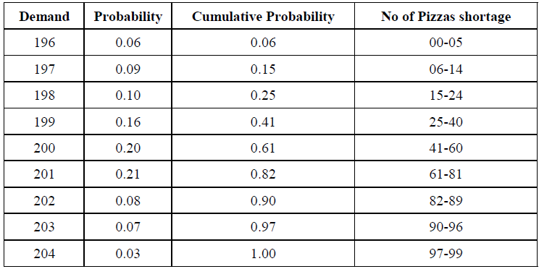

Selecting 15 random numbers from random numbers table and simulate the production per day as shown in table below.

**Simulation of Production Per Day**

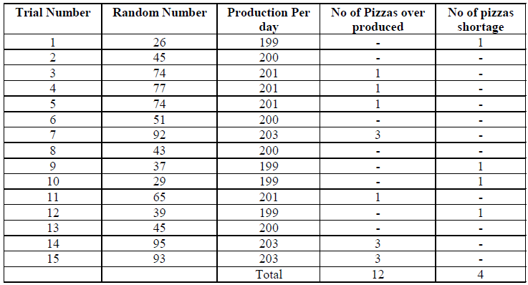

The average number of pizzas produced more than requirement  
= 12/15  
= 0.8 per day  
The average number of shortage of pizzas supplied  
= 4/15  
= 0.26 per day